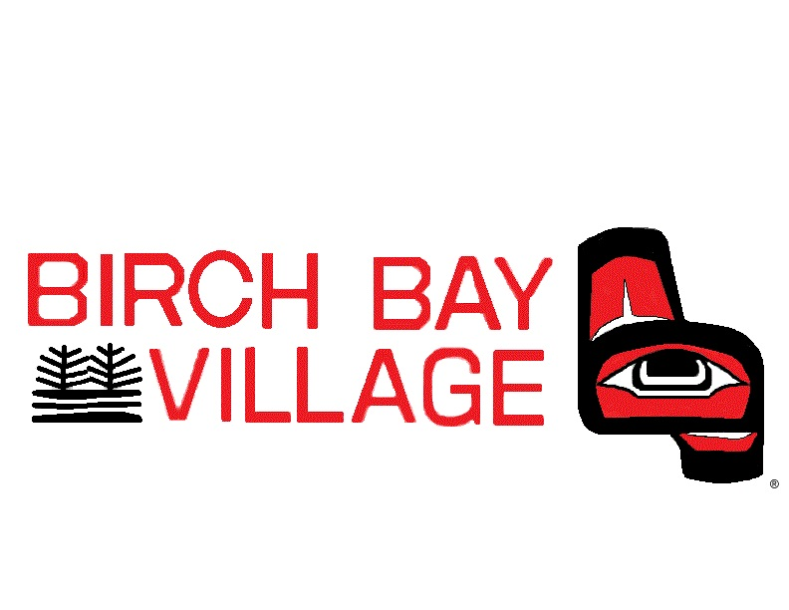

WASHINGTON

Assistant General Manager

Supplemental Essay Questions

In order to get a better sense of your writing skills and additional insights into your experience, please answer the following question. Limit your response to no more than a single page and upload your answer as part of your online application by May 11, 2025 (first review, open until filled).

- Please tell is why you are interested in this position and why it is a good time in your career to join the Birch Bay Village Community Club as their Assistant General Manager.

- Please describe your experience managing and/or balancing your daily responsibilities while also maintaining strong, professional, and responsive customer service.

