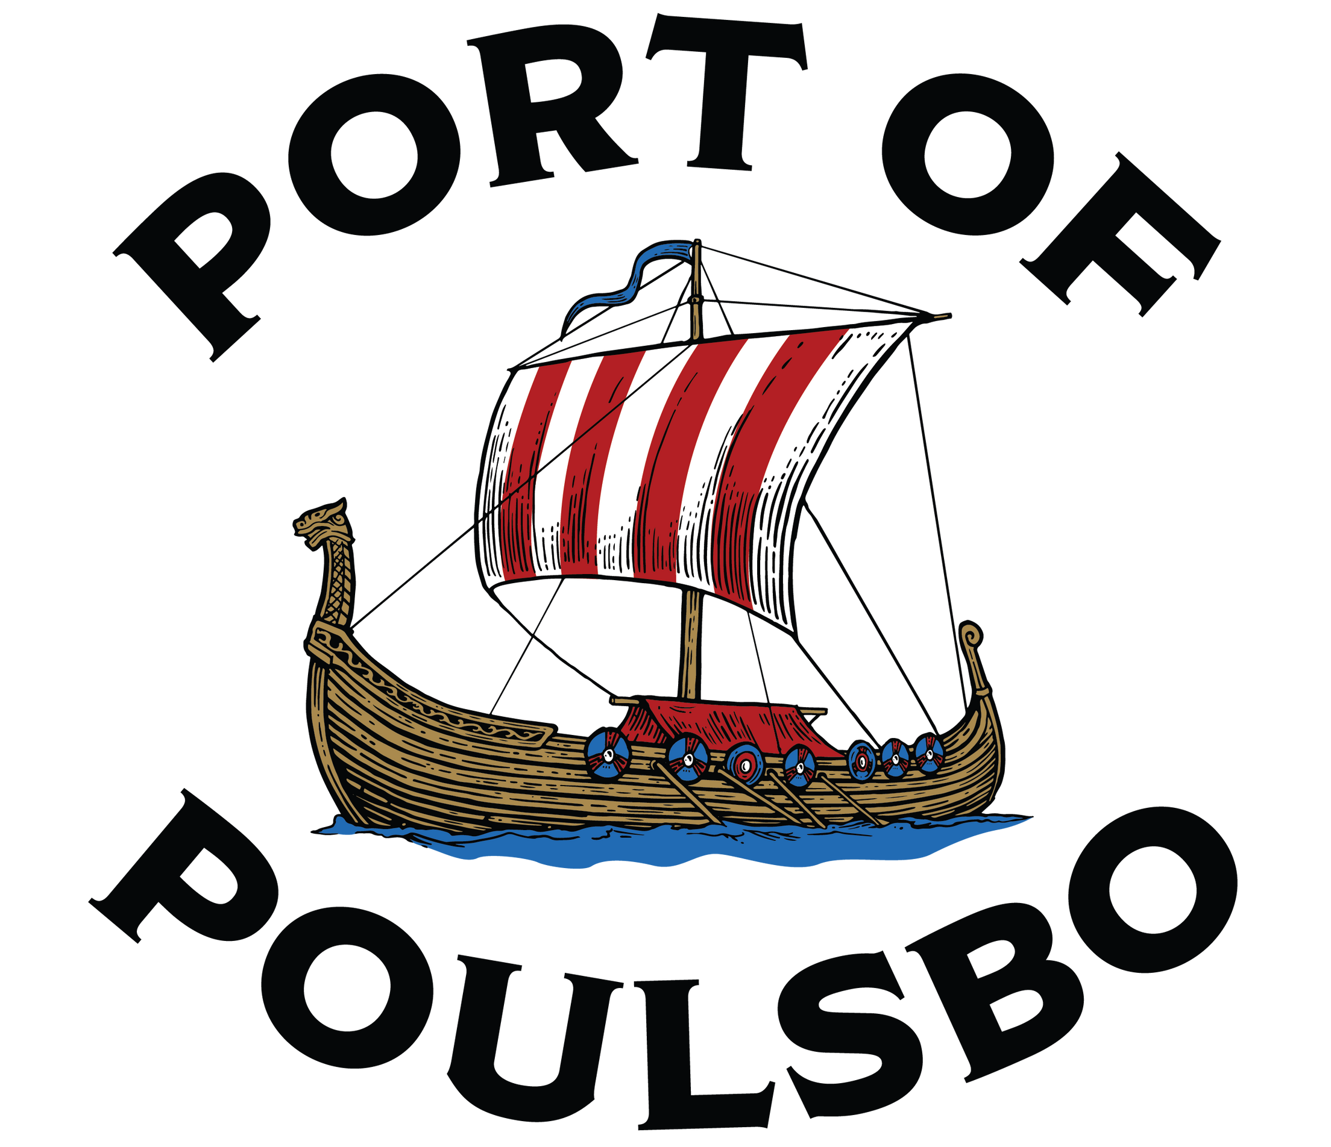
WASHINGTON

Port Manager

Supplemental Essay Question

In order to get a better sense of your writing skills and additional insights into your experience, please answer the following question. Limit your response to no more than a single page and upload your answer as part of your online application by April 27, 2025 (first review, open until filled).

- Why is now a good time in your career to consider this position, and what makes you the ideal candidate for this role based on what is outlined in the position profile’s “Ideal Candidate” section?

