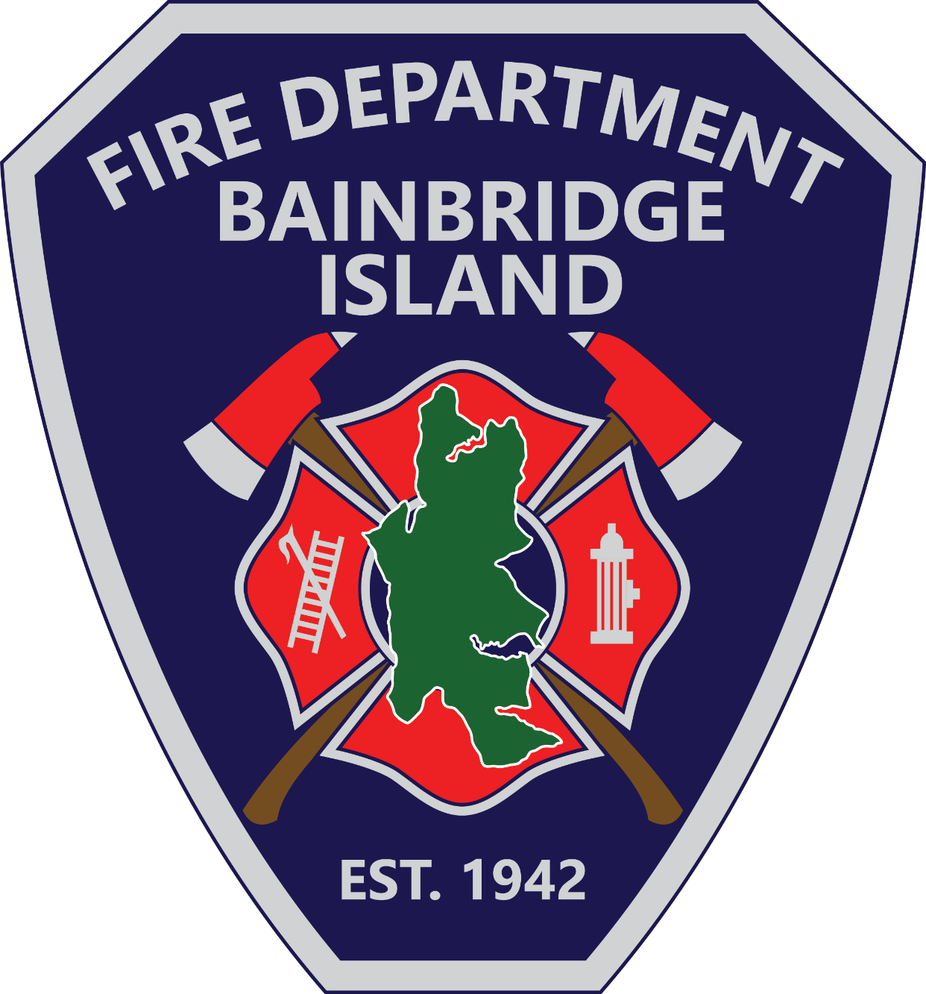

Human REsources Manager

Supplemental Essay Questions

In order to get a better sense of your writing skills and additional insights into your experience, please answer the following questions. Limit your responses to no more than a single page per question and upload your answers as part of your online application by April 6, 2025 (first review, open until filled).

- Please tell us why you are interested in this position and why it is a good time in your career to come to the Bainbridge Island Fire Department as their Human Resources Manager.

- Please give a brief overview of your experience in employee relations, training, compensation, recruitment, benefits administration, and compliance with employment laws.

