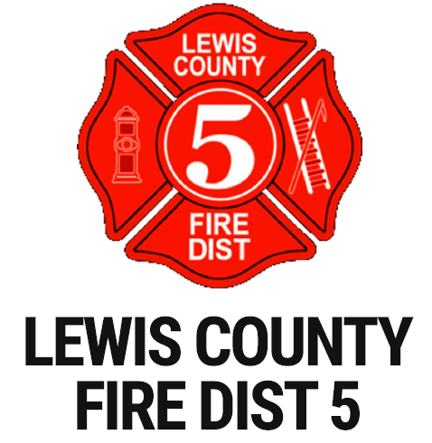
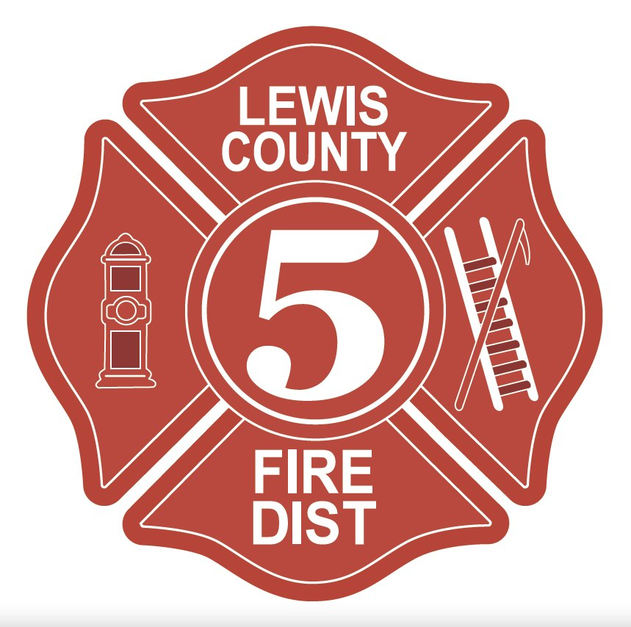

WASHINGTON

Fire Chief

Supplemental Essay Questions

In order to get a better sense of your writing skills and additional insights into your experience, please answer the following questions. Limit your responses to no more than a single page per question and upload your answers as part of your online application by April 13, 2025 (first review, open until filled).

1. Please tell us why you are interested in this position and why it is a good time in your career to come to Lewis County Fire District 5 as their next Fire Chief.

- LCFD5 has strong community support, demonstrated by the successful passage of its EMS and Fire Levy in recent years. As Fire Chief, how would you maintain and strengthen this trust while leading the District through key initiatives, such as strategic planning, operational improvements, and community engagement?

