
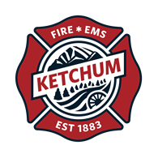

Fire Chief

Supplemental Essay Questions

In order to get a better sense of your writing skills and additional insights into your experience, please answer the following questions. Limit your responses to no more than a single page per question and upload your answers as part of your online application by April 27, 2025 (first review, open until filled).

- Please tell us why you are interested in this position and why it is a good time in your career to come to BC South as their next Fire Chief.

- Please share your experience or background related to mergers and consolidations, including if you have ever worked in a recently consolidated fire district. If not, what challenges do you expect to encounter if selected as BC South’s next Fire Chief?

