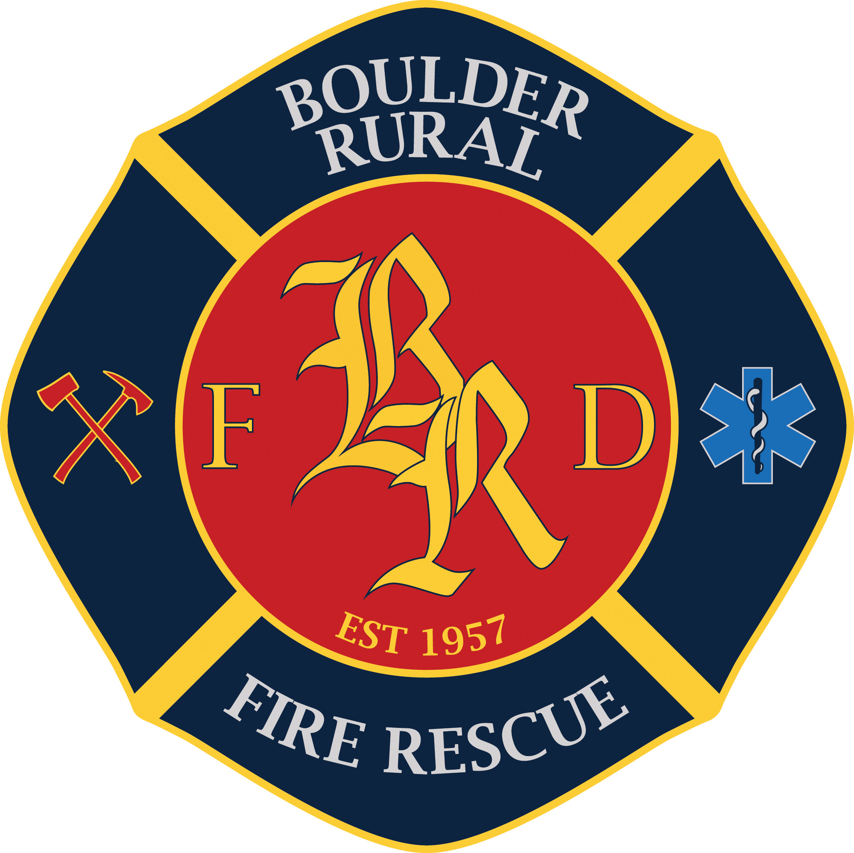

Fire Chief

Supplemental Essay Questions

In order to get a better sense of your writing skills and additional insights into your experience, please answer the following questions. Limit your responses to no more than a single page per question and upload your answers as part of your online application by March 2, 2025 (first review, open until filled).

- Please tell us why you are interested in this position and why it is a good time in your career to come to Boulder Rural Fire Rescue.

- The incoming Fire Chief will be responsible for assessing operational efficiencies and enhancing partnerships with surrounding agencies. How would you lead BRFR in these efforts while ensuring the agency remains adaptable and prepared for future challenges?

- BRFR takes great pride in its high-quality ALS first response and transport services. To sustain the program, increasing the number of paramedics will be essential to reduce the current reliance on mandatory overtime. As Fire Chief, how would you approach this challenge while maintaining both service excellence and the well-being of staff?

