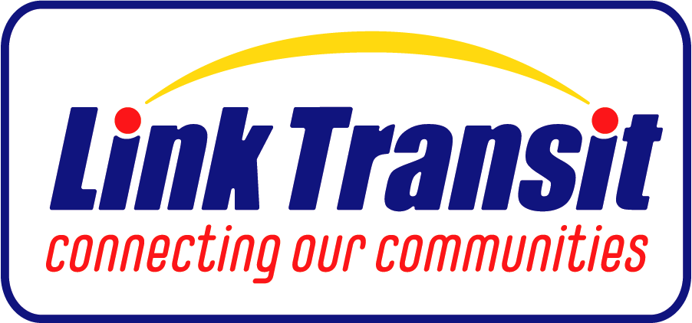
Wenatchee, WA

Planning Manager

Supplemental Essay Questions

In order to get a better sense of your writing skills and additional insights into your experience, please answer the following questions. Limit your responses to no more than a single page per question and upload your answers as part of your online application by February 23, 2025 (first review, open until filled).

- Please tell us why you are interested in this position and why it is a good time in your career to come to Link Transit as their next Planning Manager.

- Please describe your experience leading long-range planning projects and implementing strategic recommendations. How have you collaborated with key agencies and effectively supervised planning staff to achieve organizational goals in your previous roles?

