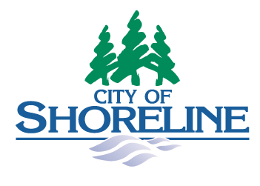

Administrative SErvices Director

Supplemental Essay Questions

In order to get a better sense of your writing skills and additional insights into your experience, please answer the following questions. Limit your responses to no more than a single page per question and upload your answers as part of your online application by November 10, 2024 (applications reviewed as submitted, open until filled.)

- Why do you believe this is the right time in your career to pursue the Administrative Services Director role with the City of Shoreline?

- Please provide a brief overview of how your experience and skills align with the upcoming projects mentioned in the position profile that this role will lead or contribute to.

