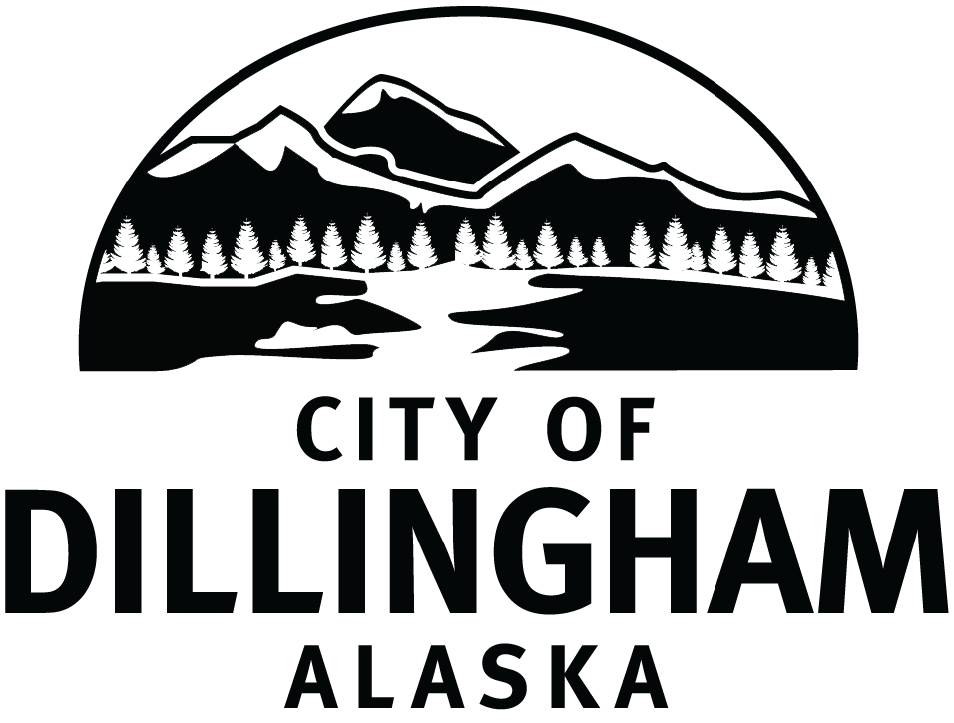

City Manager

Supplemental Essay Questions

In order to get a better sense of your writing skills and additional insights into your experience, please answer the following questions. Limit your responses to no more than a single page per question and upload your answers as part of your online application by November 17, 2024 (first review, open until filled).

- Please tell us why you are interested in this position and why it is a good time in your career to come to the City of Dillingham as their next City Manager.

- The successful candidate must be familiar with the dynamics of small communities and be able to navigate the local politics, particularly as someone who may be from outside the area. Please give a brief overview of your experience working alongside various strong-minded groups, finding the middle ground, and gaining acceptance with varying personalities.

