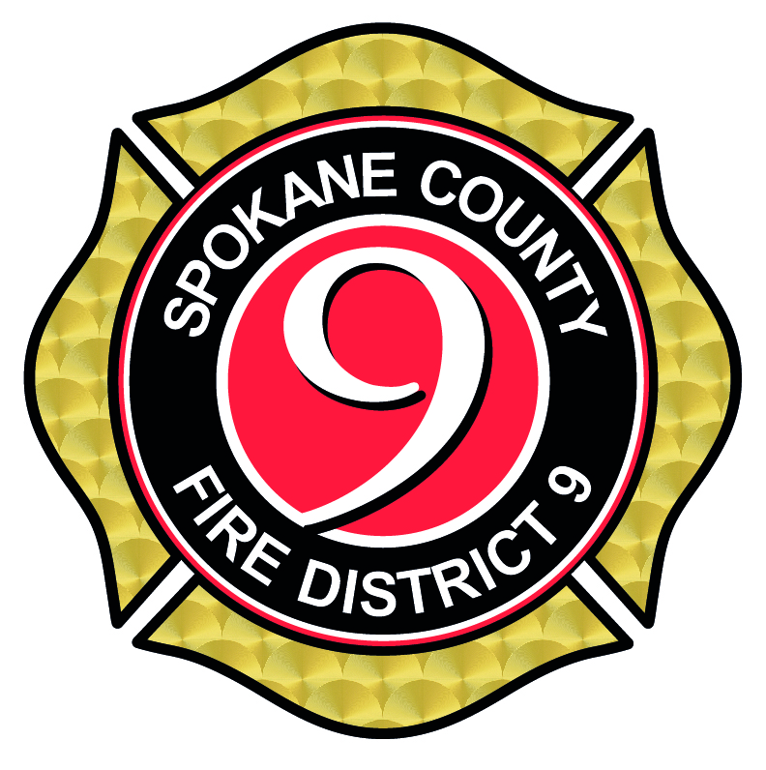

Fire Chief

Supplemental Essay Questions

In order to get a better sense of your writing skills and additional insights into your experience, please answer the following questions. Limit your responses to no more than a single page per question and upload your answers as part of your online application by October 6, 2024 (first review, open until filled).

- Please tell us why you are interested in this position and why it is a good time in your career to come to Spokane County Fire District 9.

- Please describe your administrative experience and any significant accomplishments you have had. Note, these accomplishments can be listed in the form of bullet points.

- Please describe your approach to managing change in a growing organization.

