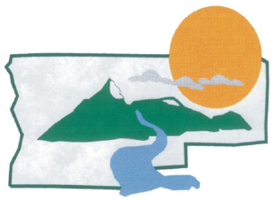
JEFFERSON COUNTY
OREGON

Community Development Director

Supplemental Essay Questions

In order to get a better sense of your writing skills and additional insights into your experience, please answer the following questions. Limit your responses to no more than a single page per question and upload your answers as part of your online application by November 4, 2024 (first review, open until filled).

1. What have you learned about Jefferson County that makes you interested in this position, and why is now a good time in your career to consider applying for this position?

- While Jefferson County is rural with many constraints on land use within the county, the County still has the need to develop its tax base and the area's economy. As the Community Development Director, how might you provide guidance and help the Commissioners with this challenge?

