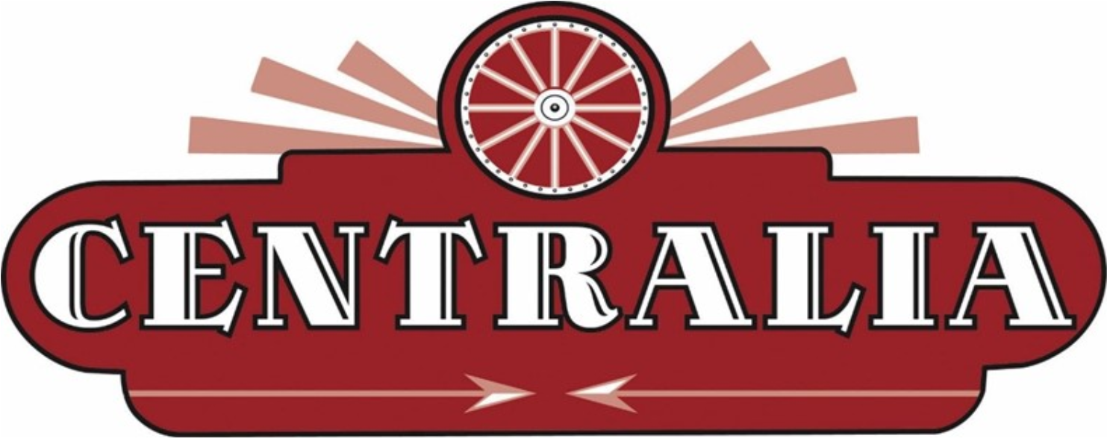
Washington

City Manager

Supplemental Essay Questions

In order to get a better sense of your writing skills and additional insights into your experience, please answer the following questions. Limit your responses to no more than a single page per question and upload your answers as part of your online application by September 8, 2024 (first review, open until filled).

- Please tell us why you are interested in this position and why it is a good time in your career to come to the City of Centralia as their next City Manager.

- Centralia continues to see growth in housing and economic development and is currently in the process of updating the comprehensive plan. Please give a brief overview of your experience in this area, including utilizing a region’s strengths to further economic development and growth.

