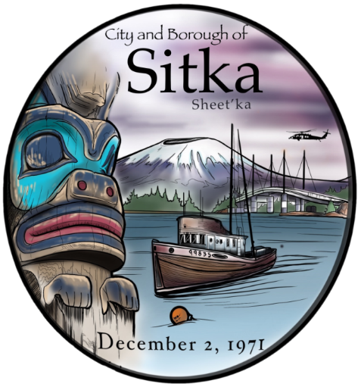
City and Borough of Sitka, Alaska

Municipal Attorney

Supplemental Essay Questions

In order to get a better sense of your writing skills and additional insights into your experience, please answer the following question. Limit your response to no more than a single page per question and upload your answers as part of your online application by July 21, 2024 (applications reviewed as submitted, open until filled).

- What have you learned about the City and Borough of Sitka that makes you interested in this position, and why is now a good time in your career to consider this position? If selected for this position, are you fully committed to relocating to Sitka?

