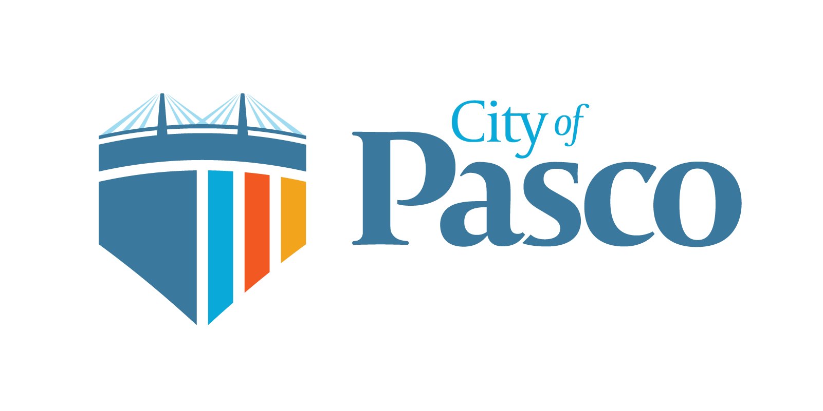
WASHINGTON

Human Resources Director

Supplemental Essay Questions

In order to get a better sense of your writing skills and additional insights into your experience, please answer the following questions. Limit your responses to no more than a single page per question and upload your answers as part of your online application by June 25, 2023 (first review, open until filled).

- Please tell us why you are interested in this position and why it is a good time in your career to come to the City of Pasco.

- The HR Director will be responsible for implementing and maintaining a performance management system that promotes open communication, goal setting, and recognition of achievements. Please give a brief overview of your experience implementing similar systems.

- The City has strong relationships with its existing unions, and maintaining these relationships is essential. How do you ensure you maintain positive union relationships, and what is your experience in this area?

