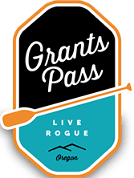
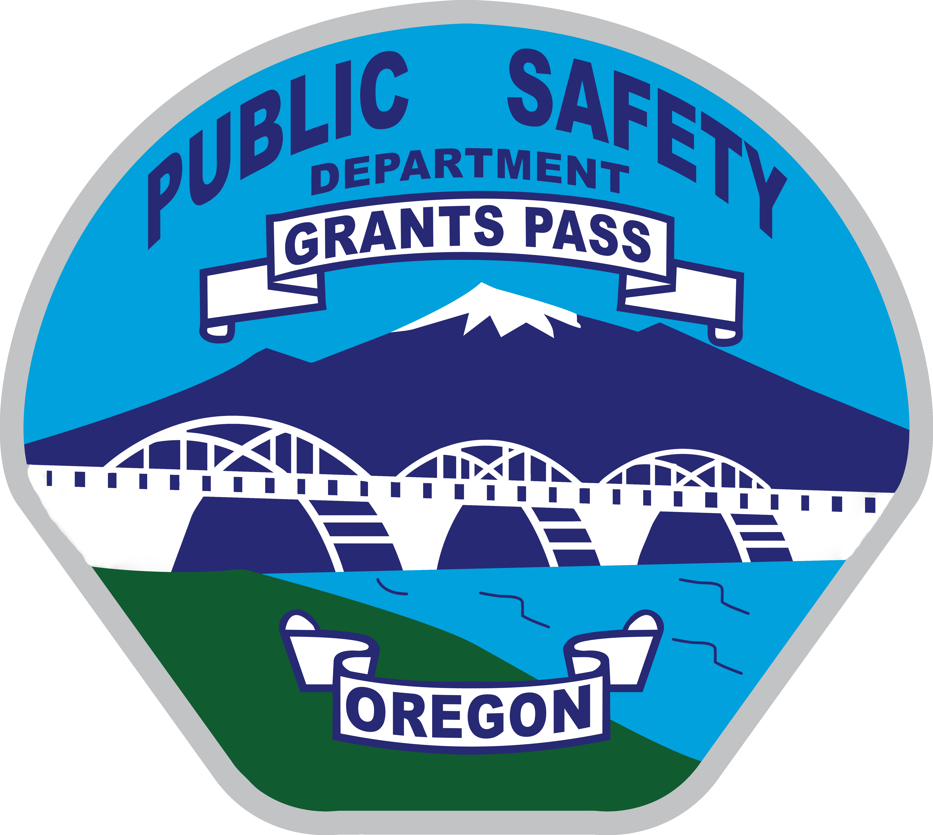

Public Safety Director

Supplemental Essay Questions

In order to get a better sense of your writing skills and additional insights into your experience, please answer the following questions. Limit your responses to no more than a single page per question and upload your answers as part of your online application by September 16, 2018 (first review, open until filled).

1. What have you learned about the City of Grants Pass that interests you and why is now a good time in your career to consider this position?

- The Department has a significant general gap between young leaders and senior leadership in both the Fire and Police divisions. The ability to provide equal mentoring between all divisions will be important in this organization as the Department works to develop a cohesive and functional team. Please describe your experience with team building and developing trust with all units in your department, and how you may tackle this challenge.

